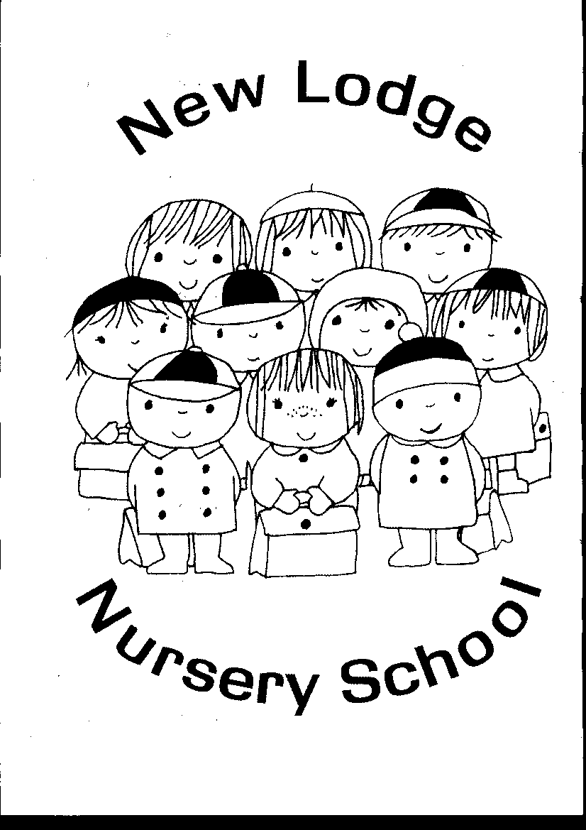
New Lodge Nursery

1st March 2024

Newsletter 9
Parent Notices
028 90743073

Easter holidays
Children will finish school at 11am on Thursday 28th March for Easter.
There will be no After School provision on this day

Mother’s Day Play & Stay
All our Mums and Grannies are invited to come to the nursery between 4th & 6th March 9:00am -10:00am for a cup of tea and play with your child.
Choose a day and time slot that suits!
Times and dates are in the front hall


Fundraising
Thank you to everyone who has bought a ticket for our Easter raffle.
The draw will take place on
Tues 26th March.
Good luck!

Parent Meetings
We will be holding our Parent Meetings on Wednesday 13th March Mrs Crown’s class
Thursday 14th March Mrs McCann’s class
Please choose a time that suits.

Warm clothes
We try to play outdoors each day. Therefore it is important for your child to have a warm coat and a hat.
We are also learning how to put our own coat on and even try to zip it up! Please continue to practise this at home.

Jiggle Wiggle Sacks
Story Sacks
Each week we will now alternate between Story Sacks and Jiggle Wiggle sacks.
Please return your sack every Wednesday so they can be shared with another child.

Easter Bunny Trip
The children will be going on an Easter Bunny trip to Stormont Estate on Tuesday 4th April.
Full school uniform must be worn.

We rely on your weekly snack money to fund all visitors to the nursery and to pay for the bus to Stormont.
Please see the attached breakdown of how we plan to spend your donations from now until the end of the year.

Dental Nurse
We are learning how to brush our teeth correctly and will be receiving new toothbrushes from the Dental Nurse.
Talk to your child about how to brush their teeth.

Family Support Hub
The Family Support Hub Network offers a range of services to support children, young people and their parents/carers. If you would like to avail of this service speak to Mrs Crown or contact the Hub directly on 90749986.
Hub co-ordinator is Edith McManus.

Safeguarding
The Designated Teacher for Child Protection is Mrs Crown. If you have any worries, questions or concerns about safeguarding or child protection issues please contact the nursery on 02890 743073.

Happy Birthday!
Happy birthday to
Anna and Ronan who celebrate their birthdays in March.


DATES FOR YOUR DIARY

MARCH

Friday 1st Sonal Sportz
Monday 4th Mother’s Day Play & Stay
Tuesday 5th Mother’s Day Play & Stay
Wed 6th Mother’s Day Play & Stay
Thursday 7th Visit from the farm
Friday 8th Sonal Sportz
Monday 11th Jump Jiggle & Jive
Tuesday 12th Gathering Drum
Wednesday 13th Mrs Crown’s Parent teacher meetings
Thursday 14th Mrs McCann’s Parent teacher meetings
Friday 15th St Patrick’s Day party
(Treats provided by nursery)
Monday 18th Children off
Tuesday 19th Visit from the librarian
Friday 22nd Sonal Sportz
Monday 25th Jump Jiggle & Jive
Tuesday 26th Mr Hullabaloo
Wednesday 27th Easter Bunny Hunt to Stormont Park
Thursday 28th Finish at 11:00am (No After School Club)
Friday 29th Children off for Easter Holidays

APRIL
Monday 8th Children return to school (Early morning & After School club resumes)
Tuesday 9th The Gathering Drum
Friday 12th Sonal Sportz
Monday 15th Jump Jiggle & Jive
Monday 15th Visit from the dental nurse
Friday 19th Sonal Sportz
Monday 22nd Jump Jiggle & Jive
Friday 26th Sonal Sportz
Monday 29th Jump Jiggle & Jive
Tuesday 30th Visit from Librarian

Ashton Centre Pantry
If you would like some information about, or to be referred to the Ashton Centre’s Pantry, please speak to Mrs Crown.

The topics we are learning are:
Spring, Farm & Easter

Discuss with your child:
Spring
The changes in the weather:
The brighter mornings and evenings.
Is it getting warmer?
Are the little buds starting to grow on trees and plants?

Farm
The different animals that live on a farm and their babies.
Horse, foal sheep, lamb
Pig, piglet duck, duckling
Cow, calf cat, kitten
The role of the farmer and what might grow on the farm.

Easter
Easter traditions
St Patrick’s Day

Colour: Green & yellow
Shape: Oval

Can you find these colours and shapes around you?

Donations
If possible, we would appreciate a donation of hand soap and a box of tissues. Thank you.

Shoes
To promote independence, children should wear shoes with no laces. This also helps to limit tripping accidents.

North Belfast food bank
If you would like to receive a voucher for The North Belfast Food Bank, please speak confidentially to Mrs Crown.

